ACKNOWLEDGEMENT

We would like to express our sincere gratitude to Ankit Sir for his valuable guidance, continuous support, and encouragement throughout the completion of our project, “Mobile Price Range Classification.” His insights and suggestions helped us understand the concepts of machine learning models and apply them effectively.
We are also thankful to our institution for providing us with the necessary resources and a collaborative environment to work on this project.
We appreciate the dedication and efforts of all our group members, whose contributions made this project successful:
- Palak Machhiwal – Report Writing & Documentation
- Yash Pratap Singh Thakur – Coder / ML Model Implementation
- Bhoomi Agarwal – Presentation Designing
- Chandan Karan – Data Collection & Data Management
- Hrishab Jagtap – Model Evaluation & Testing
Each member worked with responsibility and teamwork, ensuring the timely and accurate completion of the project.
Finally, we would like to thank everyone who directly or indirectly supported us during this project. Their help and encouragement motivated us to give our best.

Table of Contents
S.NO | CONTENT
1. | Introduction Of Project
2. | Problem Statement
3. | Dataset Description
4. | Data Collection
5. | Data Preprocessing  Data Checking  Data Cleaning:-  Verify Feature Unit:-  Unit Conversion From Mb To Gb:-  Exploratory Data Analysis (Eda)  Feature Engineering:-  Encoding The Target Variable  Dataset Splitting (Train–Test Split)  Standardization:-
6. | Train All Five Model:-
7. | Hyper Tuning :-
8. | Cross-Validation Comparison:-
9. | Finale Test Evaluation:-
10. | Confusion Matrix:-
11. | Classification Report

INTRODUCTION OF PROJECT
- WHAT IS MOBILE PRICE CLASSIFICATION?
Mobile Price Classification is a machine learning task in which mobile phones are categorized into different price ranges such as low, medium, or high based on their technical specifications. By analyzing features like RAM, storage, processor score, and battery power, a model can predict which price category a mobile belongs to. This helps in understanding the market value of the device using data-driven methods.
- WHY IS IT NEEDED?
Mobile Price Classification is needed because it helps identify the pricing segment of a mobile phone without manually checking every specification.
- For consumers, it provides clarity on whether a mobile is budget-friendly, mid-range, or premium.
- For manufacturers and sellers, it supports pricing strategy, product positioning, and competitive analysis.
- For analysts, it helps study trends and understand how different features impact price.
Overall, it automates and simplifies the process of determining a mobile’s price category.
- WHAT FEATURES ARE USED?
Main features used in the project:
- RAM: Measures how well the phone can multitask.
- Storage: Determines how much data/apps the phone can hold.
- Processor Score: Indicates the phone’s processing speed and power (clock speed + number of cores).
- Battery Power: Represents battery capacity and expected usage time.
- Price Range: The target variable representing low, mid, or high price category.

In summary, mobile price classification helps us understand how key technical features determine the overall price category of a mobile phone, making the prediction process accurate and efficient.

Problem Statement

The objective of this project is to build a machine learning-based classification system that can accurately predict the price range of a mobile phone as Low, Medium, or High.
The classification is performed using key technical specifications of mobile phones, including RAM, internal storage, and processor performance score. These features play a major role in determining the cost and market category of a mobile device.
To achieve this objective, the project implements and compares the following five machine learning models:
- Linear Regression / Classification
- Logistic Regression/Classification
- Decision Tree
- Random Forest
- K-Nearest Neighbors (KNN)
Each model is trained and evaluated to determine its effectiveness in classifying mobile phones into the correct price range. The final goal is to identify the most accurate and reliable model based on performance metrics such as accuracy, confusion matrix, and classification report.

Dataset Description

- Dataset Description
The dataset contains specifications of various mobile phones along with their price range category. Each row represents one mobile device, and each column provides a different feature such as RAM, storage, processor score, battery power, etc. The dataset also includes a target column called price_range, which classifies mobiles into Low, Medium, or High price categories. This dataset is suitable for machine learning tasks related to classification.

- Source
The dataset is taken from publicly available mobile specification datasets typically used for mobile price prediction and machine learning research.
- Features
Main Features Used in the Project:
- RAM
- Storage (internal memory)
- Processor Score (clock_speed + number of cores)
- Battery Power
- Price Range (target variable)
Other Features (Only Names):
Bluetooth (blue), Dual SIM (dual_sim), Front Camera (fc), 3G (three_g), 4G (four_g), Rear Camera (pc), Screen Height (sc_h), Screen Width (sc_w), Mobile Weight (mobile_wt), Touch Screen (touch_screen), WiFi (wifi), Pixel Height (px_height), Pixel Width (px_width), Mobile Depth (m_dep), Talk Time (talk_time)

Why We Selected These Features
The main features—RAM, storage, processor score, and battery power—were selected because they are the most important factors that directly influence a mobile phone’s performance and price. RAM and processor determine the speed of the device, storage affects usability, and battery power impacts user experience. These features are highly correlated with mobile pricing and allow machine learning models to classify price ranges accurately. The other features were included in the dataset but were not the primary focus of our project.

DATA COLLECTION
SOURCE OF DATA:
- GitHub

DATASET SIZE:
- ROWS: 2000
- COLUMNS: 21
COLUMN NAME:
- Battery_power
- blue
- clock_speed
- dual_sim
- fc
- four_g
- int_memory
- m_dep
- mobile_wt
- n_cores
- pc
- px_height
- px_width
- ram
- sc_h
- sc_w
- talk_time
- three_g
- touch_screen
- Wifi
- price_range (target)

Q.1 WHY 2000 ROWS?
- Dataset is public benchmark for mobile price classification.
- 2000 samples are enough to:
- Train ML models reliably
- Avoid overfitting
- Run cross-validation properly
- Balanced classes (low/mid/high/veryhigh) → fair learning.
Q.2 WHY 21 COLUMNS?
- 20 input features describe a phone completely:
- Hardware (RAM, battery, cores, clock)
- Display (px_height, px_width, sc_h, sc_w)
- Connectivity (3G, 4G, WiFi, Bluetooth)
- Physical (weight, depth)
- 1 target column:
price_range (low/mid/high/veryhigh)
Q.3 WHY NOT FEWER OR MORE?
- Fewer features → information loss → poor accuracy.
- More features → noise, overfitting.
- This dataset already has optimal, engineered features.
Q.4 WHY 4 CLASSES (LOW, MID, HIGH, VERY HIGH) INSTEAD OF 3 CLASSES (LOW/MID/HIGH)?
- Better price resolution
- Mobile prices don’t fall cleanly into just low–mid–high.
- “Very high” separates flagship phones from normal high-end phones.
- More realistic market segmentation
- Budget
- Mid-range
- Premium
- Flagship
- Richer learning for the model
- 4 classes force the model to learn finer differences in specs.
- 3 classes would merge high and flagship phones → information loss.
- Academic advantage
- Multiclass (4-class) classification looks stronger and more advanced
- Better for confusion matrix, CV, and evaluation discussion.
- Four price categories were used to capture finer distinctions between mobile phone price segments, especially to separate premium and flagship devices, which would be lost in a three-class setup.”
Q.5 WHY WE USED 21 FEATURES WHEN PROBLEM STATEMENT MENTIONS ONLY RAM, PROCESSOR SCORE, AND STORAGE?
1) Problem statement is simplified
- “RAM, processor score, storage” are primary indicators, not the only ones.
- Problem statements are abstracted versions of real-world pricing.
2) Mobile price depends on multiple factors
- Real pricing also depends on:
- Battery capacity, Screen resolution & size, Camera specs, Connectivity (4G/5G, WiFi)
- , Weight & build, CPU cores & clock speed
- Ignoring them would make the model unrealistic.
3) ML models learn importance automatically
- We don’t force the model to use all features equally.
- Feature importance later shows:
- RAM & battery are dominant
- Others contribute less
- So irrelevant features are down-weighted automatically.
4) Using fewer features can reduce accuracy
- 3-feature model = underfitting
- 21-feature model = better representation
- We verified this using:
- Cross-validation
DATA PREPROCESSING
- DATA CHECKING
Before training any machine learning model, the dataset is carefully checked to ensure data quality and reliability.
- Checking for Missing Values:
Missing values can confuse machine learning algorithms and lead to incorrect pattern learning, resulting in poor model accuracy. Therefore, the dataset is examined to detect any null or empty entries.
- Checking for Duplicate Row:
Duplicate records can bias the model by repeating the same information multiple times. This may cause overfitting and produce misleading performance results.
- Purpose of Data Checking: The main purpose of checking missing values and duplicate rows is to ensure that the dataset is clean, consistent, and unbiased before applying preprocessing and model training.

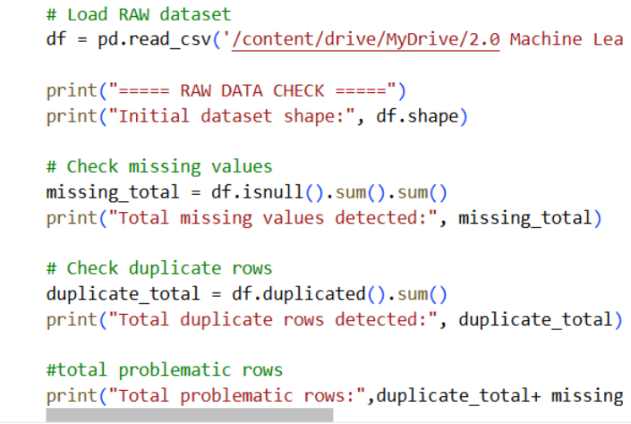

- DATA CLEANING:-
The purpose of data cleaning is to ensure that the dataset is accurate, consistent, and suitable for machine learning modeling. High-quality data is essential for obtaining reliable and unbiased results from machine learning algorithms.
Handling Missing Values
Rows containing missing or null values were identified and removed from the dataset. Machine learning algorithms cannot operate reliably when data is incomplete, as missing values distort underlying patterns and negatively impact model accuracy. Removing such entries ensures that all models are trained on complete and meaningful data.
Removing Duplicate Records
Duplicate rows present in the dataset were removed. Duplicate data can introduce bias by over-representing certain samples, which may lead to overfitting and incorrect learning behavior. Eliminating duplicates ensures that each data instance contributes equally to the training process.

CODE :-

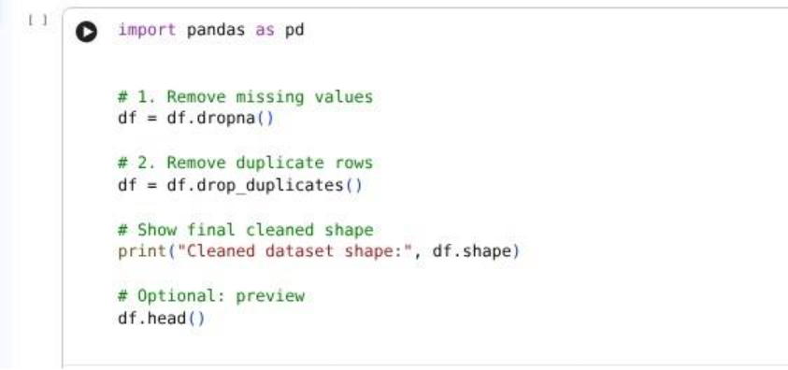

OUTPUT:-
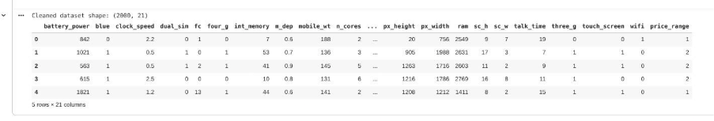

Q1. WHAT IS MEANT BY REMOVING MISSING VALUES?
Removing missing values means deleting rows that contain null or empty data entries.
Q2.WHY ARE MISSING VALUES REMOVED FROM THE DATASET?
Machine learning algorithms cannot work reliably with missing data. Missing values distort patterns in the dataset and reduce the accuracy of the model.
Q3. WHAT IS MEANT BY REMOVING DUPLICATE ROWS?
Removing duplicate rows means deleting repeated records that appear more than once in the dataset.
Q4. WHY ARE DUPLICATE ROWS REMOVED?
Duplicate records bias the model by giving extra importance to certain examples. This can cause overfitting and poor generalization.
Q5. WHY IS DATA CLEANING IMPORTANT BEFORE MODEL TRAINING?
Data cleaning ensures that the dataset is unbiased, reliable, and suitable for transformations and model training.

- VERIFY FEATURE UNIT:-
Feature unit verification is the process of ensuring that all values within a single feature column are measured using the same unit. While different columns may have different units, a single column must not contain mixed units, as this can confuse the machine learning model and lead to incorrect learning.
In this project, all numerical feature columns were carefully analyzed by examining their value ranges to confirm unit consistency. Features such as RAM, internal memory, battery power, screen resolution, mobile weight, screen dimensions, depth, and clock speed were checked individually.
The analysis confirmed that:
- Each feature column uses one consistent unit throughout
- No column contains mixed units (e.g., MB and GB together in the same column)
- All values fall within realistic and expected ranges for mobile phone specifications
Therefore, the dataset was found to be unit-consistent and reliable, making it suitable for further preprocessing steps such as conversion, feature engineering, and model training.

CODE:-

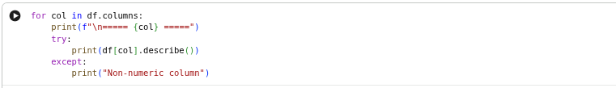

OUTPUT:-

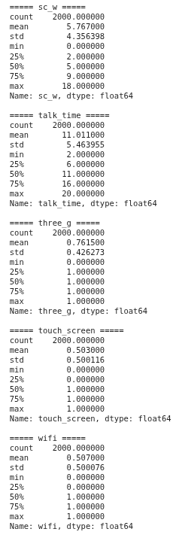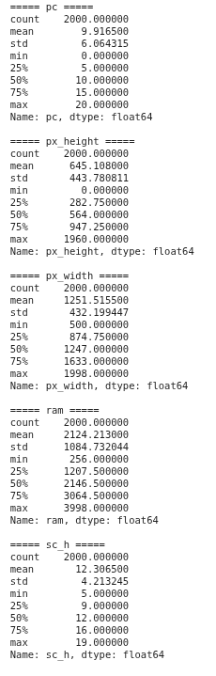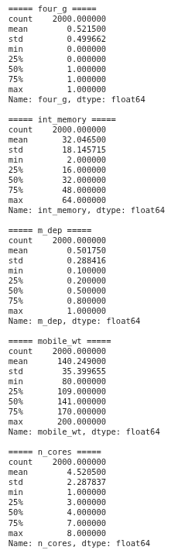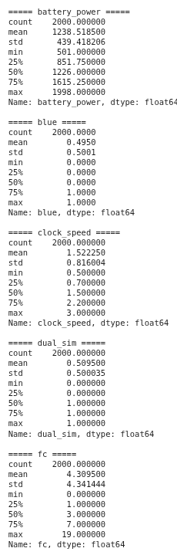

CHECKING EACH COLUMN UNIT USING VALUE RANGE
I will tell you what the unit is and how I know.

1. battery_power
Range: 501 → 1998 This perfectly matches mAh range of older smartphones. ✔ Unit is consistent: mAh
2. ram
Range: 256 → 3998 This is MB, because:
- Modern phones in GB would show 1 → 12
- You have values like 256, 1207, 3064 → these are MB numbers
✔ Unit is consistent: MB You must convert to GB later.
3. int_memory
Range: 2 → 64 Phones in this dataset typically had 4GB, 8GB, 16GB, 32GB, 64GB.
✔ Unit is consistent: GB
No MB values present. No mixed units.
4. px_height
Range: 0 → 1960 0 means missing or low-resolution placeholders.
✔ Unit: pixels
5. px_width
Range: 500 → 1998 This matches old phone widths.
✔ Unit: pixels
6. sc_h (screen height in cm-like arbitrary units)
Range: 5 → 19 Phones do NOT have 19-inch screens, so this is not inches. This dataset uses arbitrary scaled screen dimensions.
✔ Unit: abstract units (dataset-defined)
7. sc_w
Range: 0 → 18
✔ Same: abstract units.
8. m_dep
Range: 0.1 → 1.0 Phone thickness around 7–10 mm → 0.7–1.0 cm.
✔ Unit: cm
9. mobile_wt
Range: 80 → 200
✔ Unit: grams
10. clock_speed
Range: 0.5 → 3.0
✔ Unit: GHz
11. price_range (target)
Values 0,1,2,3
✔ No units. Only categories.

FINAL — UNIT CONSISTENCY RESULT
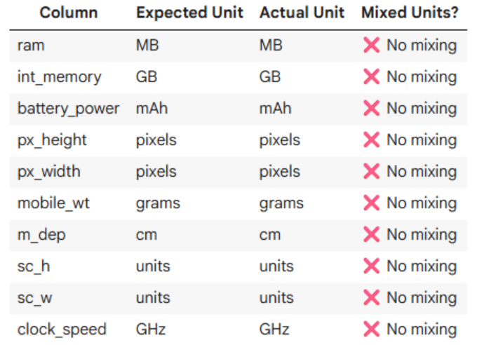
Q1: WHAT IF WE USE RAM AS MB ONLY WITHOUT CONVERTING IT ? WHY THE DATASET USES RAM IN MB INSTEAD OF GB?
ANSWER: Because this dataset comes from older smartphones (2015 era) where:
256 MB
512 MB
1024 MB
2048 MB
3072 MB
4096 MB
were common values.
GB-level RAM existed but was usually shown in MB in early datasets.
Q2: DOES IT AFFECT MODEL PERFORMANCE?
ANSWER: No — ML models don’t care if RAM is in MB or GB, as long as:
Units are consistent
You standardize/normalize later
But MB is a large number (3000+), so converting to GB reduces scale, making graphs and engineering easier.
Q3: WHY YOU CONVERT RAM TO GB?
ANSWER:
- More readable----3072 MB → 3 GB
- Better feature engineering Ratios like: ram_gb / int_memory_gb make sense only if both are in the same unit system.
- Scaling becomes smooth Instead of values ~3000, you get values ~3.
- Industry standard representation Everyone uses GB for RAM today.

- UNIT CONVERSION FROM MB TO GB:-
Unit conversion from Megabytes (MB) to Gigabytes (GB) is the process of changing memory values into a common and standard unit so that all data is consistent and easy to interpret.
Since 1 GB = 1024 MB, the conversion is done by dividing the MB value by 1024

- Overwrite original RAM column
Code:-
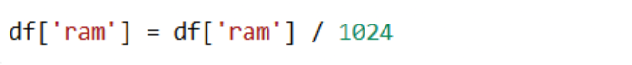

RESULT:-
- ram becomes GB
- No extra column created

Q1: WHAT IF WE USE RAM AS MB ONLY WITHOUT CONVERTING IT ? WHY THE DATASET USES RAM IN MB INSTEAD OF GB?
ANSWER: Because this dataset comes from older smartphones (2015 era) where:
256 MB
512 MB
1024 MB
2048 MB
3072 MB
4096 MB
were common values.
GB-level RAM existed but was usually shown in MB in early datasets.
Q2: DOES IT AFFECT MODEL PERFORMANCE?
ANSWER: No — ML models don’t care if RAM is in MB or GB, as long as:
Units are consistent
You standardize/normalize later
But MB is a large number (3000+), so converting to GB reduces scale, making graphs and engineering easier.
Q3: WHY YOU CONVERT RAM TO GB?
ANSWER:
- More readable----3072 MB → 3 GB
- Better feature engineering Ratios like: ram_gb / int_memory_gb make sense only if both are in the same unit system.
- Scaling becomes smooth Instead of values ~3000, you get values ~3.
- Industry standard representation: Everyone uses GB for RAM today.

- EXPLORATORY DATA ANALYSIS (EDA)
EDA (Exploratory Data Analysis) is the process of analyzing and visualizing data to understand its structure, patterns, and problems before applying machine-learning models.

- Dataset Info:
The dataset information is checked to understand the number of rows, columns, data types, and overall structure of the data.
- Missing Values Check:
Missing values are analyzed to ensure data completeness, as missing entries can negatively affect model performance.
- Statistical Summary:
Descriptive statistics such as mean, minimum, maximum, and standard deviation are examined to understand the data distribution and value ranges.
- Target Distribution (Price Range):
The distribution of the target variable (price range) is analyzed to check class balance among low, mid, and high-priced mobiles.
- Correlation Heatmap:
A correlation heatmap is used to identify relationships between features and detect highly correlated variables that influence the price range.
- Outlier summary:
An outlier summary shows the number of outliers detected in each feature of the dataset.Outliers are data points that lie far away from the normal range of values and can affect model performance.
- Feature distribution box plot:
A feature distribution box plot is a statistical visualization used to show how the values of a feature are distributed across different categories of the target variable.
- Feature Distribution Plot (Histogram with KDE):
Important features such as battery power, RAM, pixel height, pixel width, and internal memory are compared with price range to understand their impact on mobile pricing.
- Scatter plot:
A scatter plot is a graphical representation used to show the relationship between two numerical features by plotting data points on a two-dimensional plane.
Each point in the plot represents a single data sample, where:
- The x-axis represents one feature
- The y-axis represents another feature

CODE:-
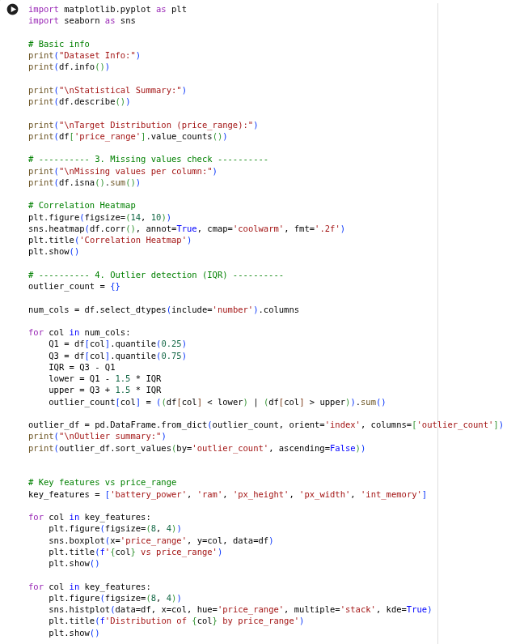
OUTPUT:-
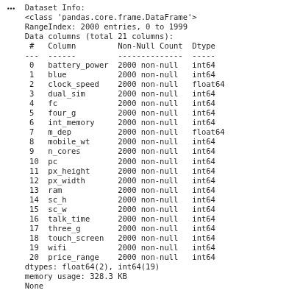
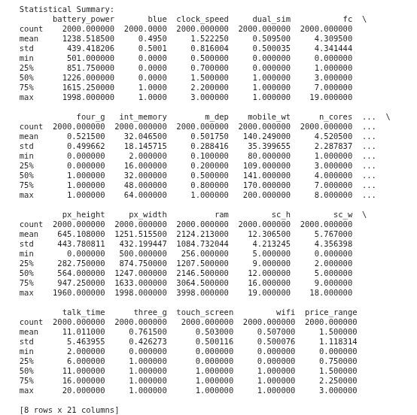

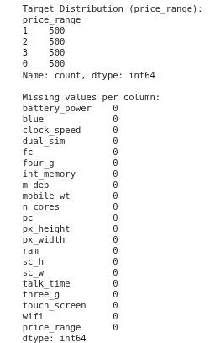

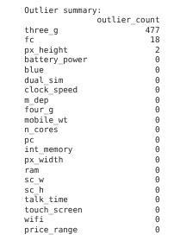

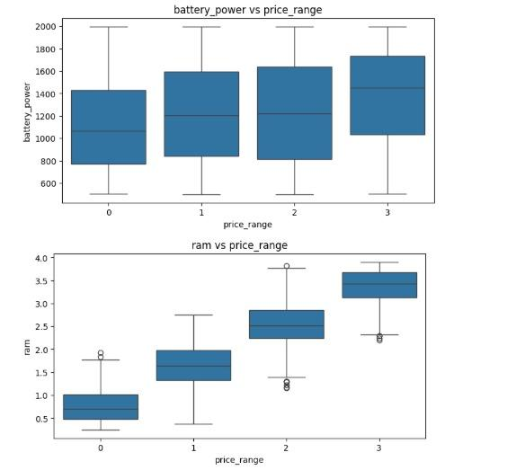
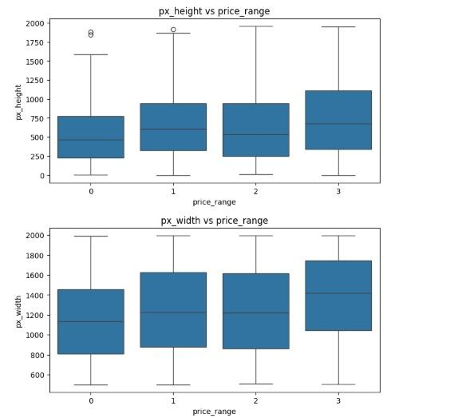

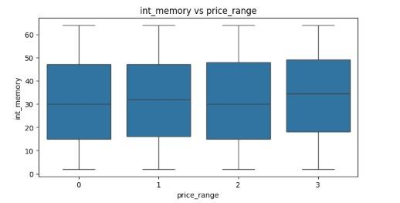

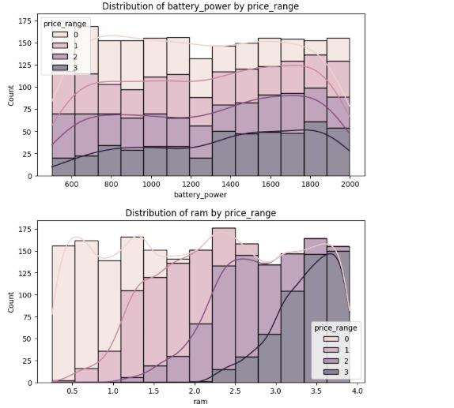

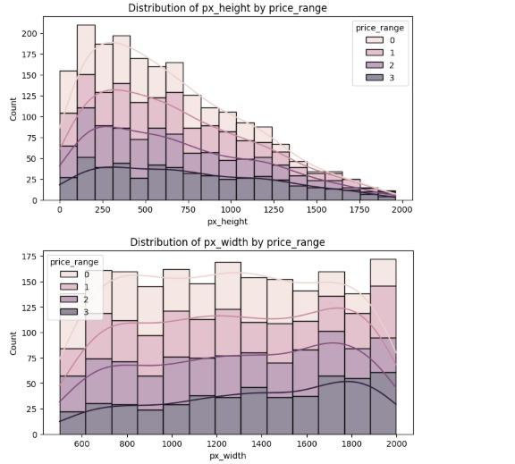
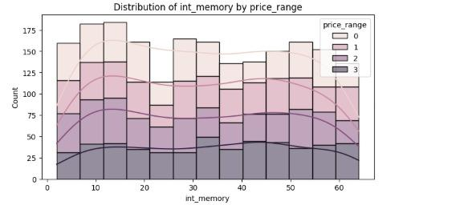

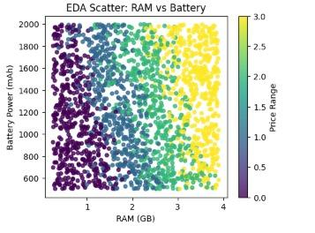
- FEATURE ENGINEERING:-
Feature Engineering is the process of transforming raw data into meaningful features that improve model performance.
In this project, f, and the target variable (price range) is encoded into numerical labels (0–3). Standardization is applied so that all features are on a similar scale, preventing any single feature from dominating the model.
Overall, feature engineering improves data quality, model accuracy, and learning efficiency.

Q.1 WHAT IT DOES?
- Combines columns
- Transforms values
- Creates ratios
- Creates interactions
- Adds logs, bins, categories
- Extracts hidden patterns the model won’t see by itself
Makes the data more meaningful
Q,2 WHY IT MATTERS?
- It increases model accuracy more than any other step.
- Example
From px_height + px_width → create resolution From battery / weight → create battery_efficiency
- In one line
Feature engineering turns raw data into smarter data so your model performs better.
CODE:-
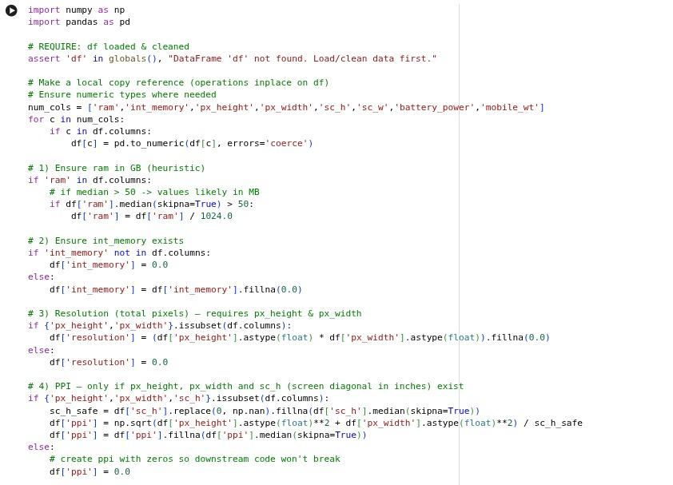
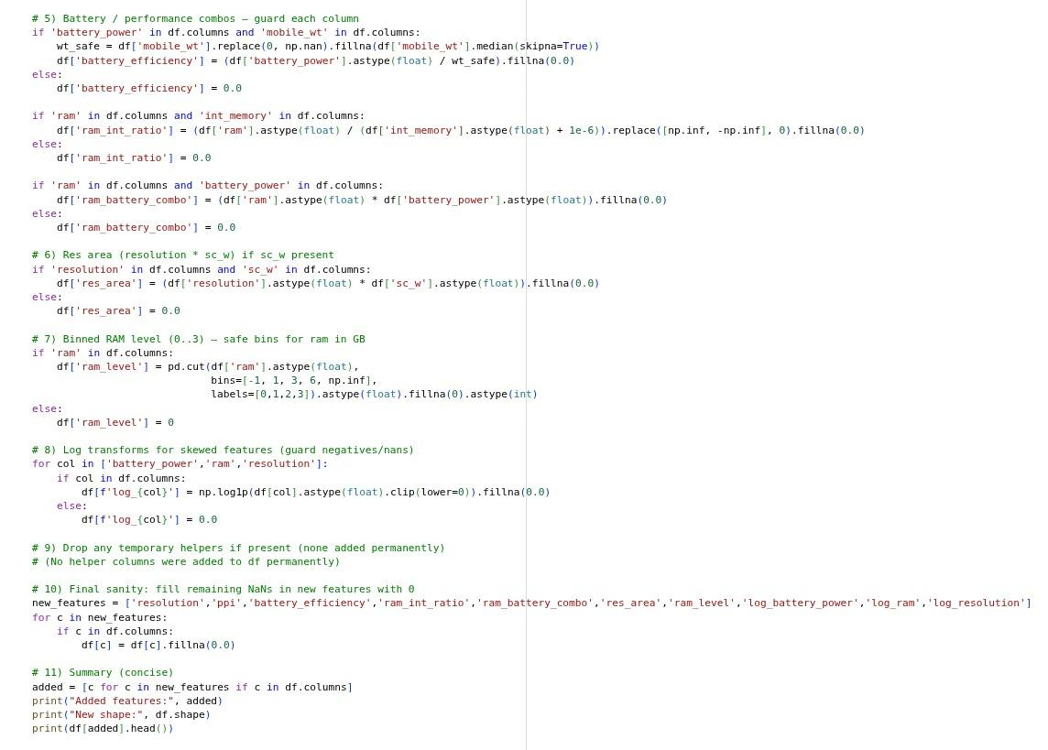

OUTPUT :-

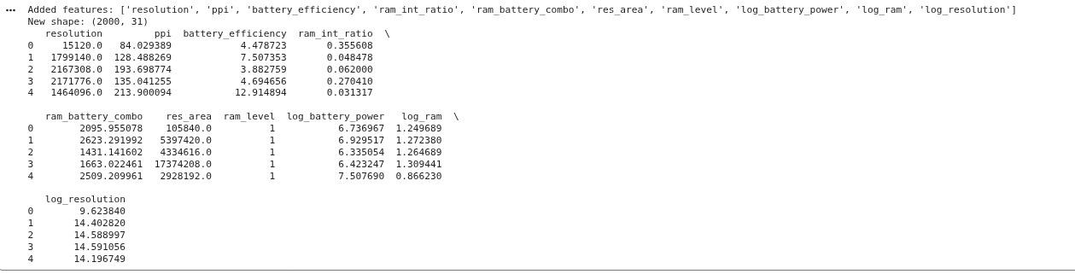
- ENCODING THE TARGET VARIABLE
In machine learning, most algorithms require the target variable to be in a numeric format. Since the price range of mobile phones is a categorical variable (Low, Mid, High), it must be converted into numerical labels before model training. This process is known as target encoding.
In this project, the target variable Price Range was encoded using label encoding, where each price category was assigned a unique numerical value. The encoding scheme used is shown below:
Price Category Encoded Value
Low Price 0
Mid Price 1
High Price 2
This encoding allows machine learning models to understand and process the target variable effectively. The encoded values represent class labels rather than numerical magnitude, making them suitable for classification algorithms such as Logistic Regression, Decision Tree, Random Forest, and K-Nearest Neighbors (KNN).

If the target was not encoded (example: "low", "medium", "high"), then:
- Model would throw an error
ML algorithms cannot train on text labels.
- Metrics like accuracy, F1 cannot compute
They expect numbers, not strings.
- Confusion matrix cannot be generated
It needs numeric classes.
- Train/Test split might work, but training would fail
Split doesn’t care about types, but models do.
- Hyperparameter tuning and cross-validation would break
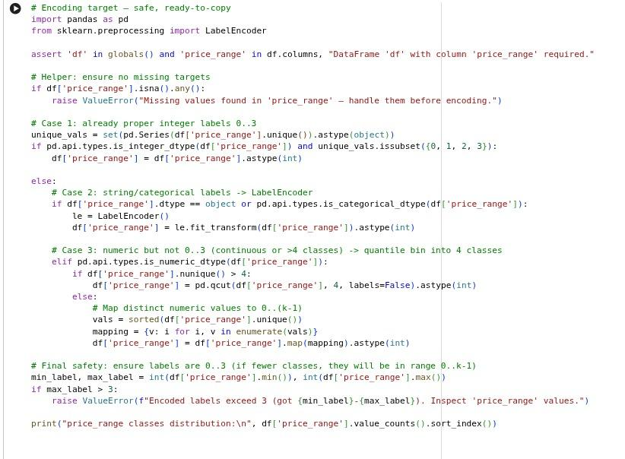
GridSearchCV expects numeric y-values.
- Some algorithms assume classes are ordered
If labels were strings, they cannot infer order

OUTPUT:-
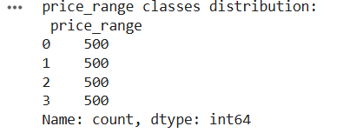
- DATASET SPLITTING (TRAIN–TEST SPLIT)
After completing data preprocessing, the dataset is divided into two separate parts known as the training dataset and the testing dataset. This step is essential to evaluate how effectively the machine learning models can classify mobile phone price ranges.
In this project, the dataset contains mobile specifications such as RAM, Storage, and Processor Score, along with the target variable Price Range (Low, Mid, High). The dataset is typically split using a 70:30 or 80:20 ratio, where:
· 70–80% of the data is used for training
· 20–30% of the data is used for testing
Training Set (80%)
- Used to train the machine learning models
- Helps the model learn patterns from input features
- Used to fit model parameters and weights
Testing Set (20%)
- Used to evaluate the model on unseen data
- Helps measure the accuracy of predictions
- Checks the real performance of the model
- Helps in detecting and avoiding overfitting
- This approach ensures a fair and reliable evaluation of the machine learning models before final selection.
CODE:-

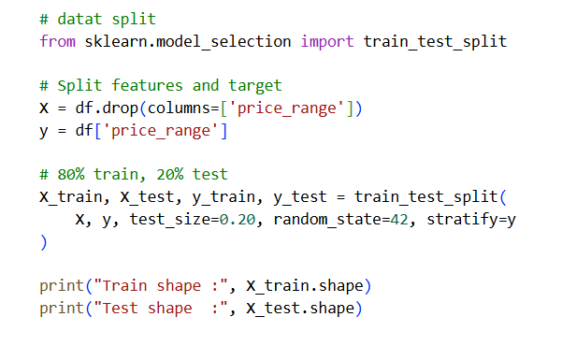

OUTPUT:-
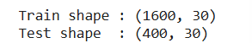
Q.1 WHY WE SPLIT?
Because if the model is tested on the same data it was trained on, accuracy will be fake and meaningless.
In short:
Train set → model learns Test set → model is judged This ensures a fair and realistic evaluation.

- STANDARDIZATION:-
Standardization is a feature scaling technique used to transform data so that each feature has a mean of 0 and a standard deviation of 1. This helps bring all features onto a common scale without changing their relative differences.
The standardization formula is:
$z=\frac{\left(mean\right)}{standard deviation}$
Standardization is important because it ensures that no single feature dominates the learning process due to larger numerical values, leading to better and more stable model performance.
Q.1WHAT IT DOES?
It puts all features on the same scale, so no feature dominates due to larger values.
Example:
- RAM = 4
- battery = 1500
Model will think battery is more important unless standardized.
After standardization:
- RAM → ~0
- battery → ~0
Both become equal scale.
Q.2 WHY IT'S NEEDED?
Algorithms like:
- SVM
- Logistic regression
- Linear regression
- KNN
- Neural networks
perform MUCH better when data is standardized.
In short
Standardization = scale all features to same range (0 mean, 1 std) for better model training.

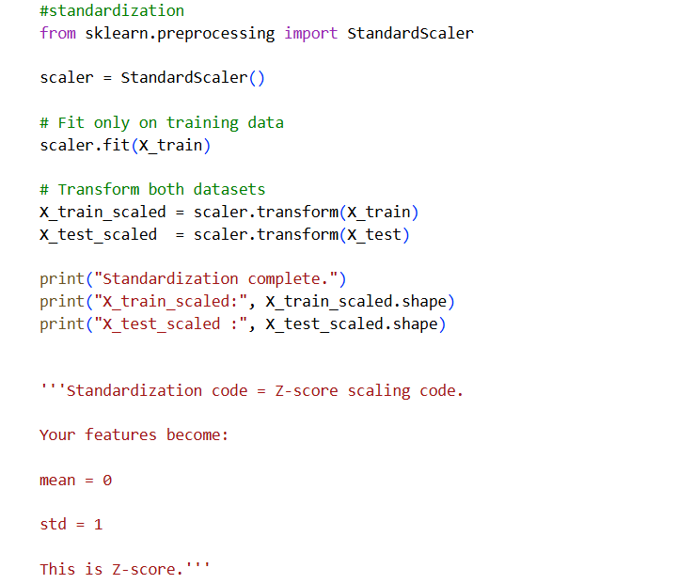
CODE:-
OUTPUT:-

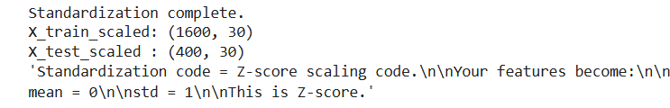

You must NOT use both. Use only ONE: Standardization OR Normalization. Never both together.
Reason (straight point-to-point):
- Standardization (Z-score) makes mean=0, std=1.
- Normalization (Min-Max) makes values 0→1.
- If you apply normalization after standardization → you completely destroy the standardization you just did.
Effect: – Your models get confused. – Scaling becomes meaningless. – Accuracy becomes inconsistent. – Pipelines break.
Industry rule: For ML models → choose ONE scaling step.
For your models (Logistic, Linear classifier, KNN): Standardization is the correct choice.
Decision Tree / Random Forest do not need scaling at all.

TRAIN ALL FIVE MODEL

In this step, five different machine learning models were trained to classify the mobile price range. These models include Linear Regression, Logistic Regression, Decision Tree, Random Forest, and K-Nearest Neighbors (KNN). Training multiple models helps compare their performance, understand different learning behaviors, and select the best-performing model. Each model learns patterns from the training data and is later evaluated on the test data to determine accuracy and reliability

CODE:-

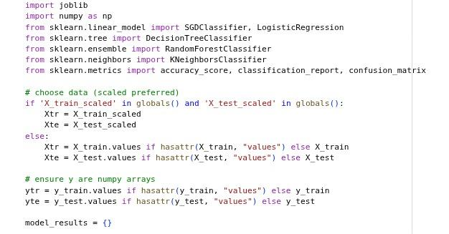

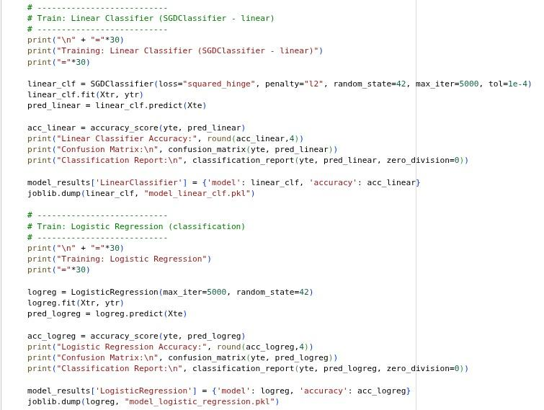

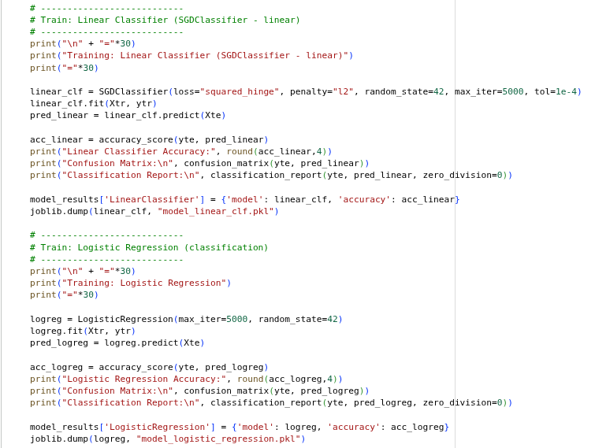
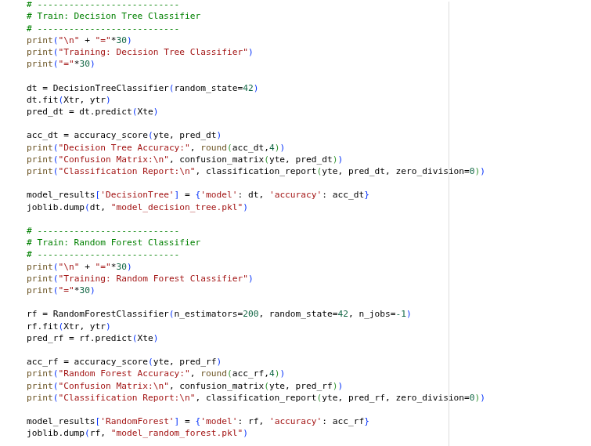

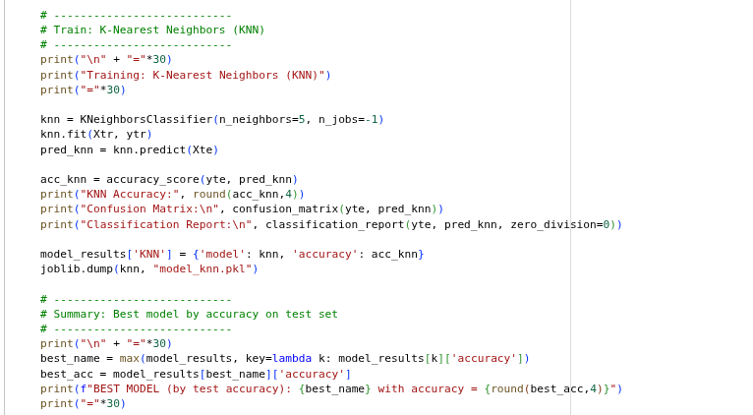OUTPUT:-
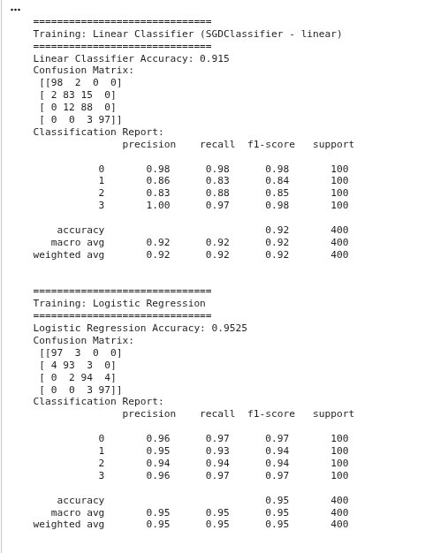
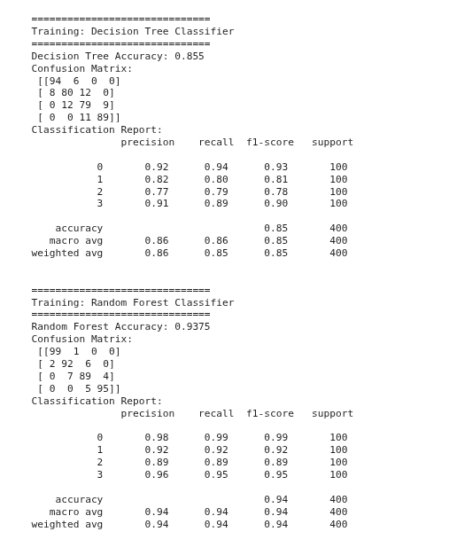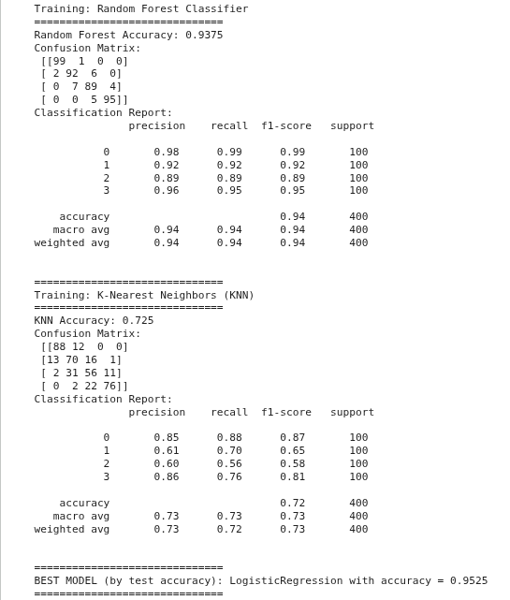

AEXPLANATION OF CODE :-
1. Importing Required Libraries
The code begins by importing essential libraries such as:
· scikit-learn classifiers (SGDClassifier, Logistic Regression, Decision Tree, Random Forest, KNN)
· Evaluation metrics like accuracy score, confusion matrix, and classification report
· joblib for saving trained models
These libraries support model training, evaluation, and storage.
2. Selecting Input Data
The code checks whether standardized datasets (X_train_scaled, X_test_scaled) are available. If present, standardized data is used because many ML algorithms perform better when features are on the same scale. Otherwise, the original datasets are used.
The target variables (y_train, y_test) are converted into NumPy arrays to ensure compatibility with all models.
3. Model Results Storage
A dictionary named model_results is created to store:
· The trained model
· Its corresponding accuracy score
This allows easy comparison between all models.
Training Individual Models
a) Linear Classifier (SGDClassifier)
A linear classification model trained using stochastic gradient descent.It is fast and used as a baseline model. Accuracy,confusion
matrix, and classification report are generated, and the model is saved.
b) Logistic Regression (Classification)
A probabilistic classification algorithm suitable for multi-class problems. The model learns decision boundaries between price categories and shows strong performance after standardization.
c) Decision Tree Classifier
A tree-based model that splits data based on feature values. It is easy to interpret but may overfit the data.
d) Random Forest Classifier
An ensemble model that combines multiple decision trees. It improves accuracy and reduces overfitting compared to a single decision tree.
e) K-Nearest Neighbors (KNN)
A distance-based model that classifies a mobile phone based on the majority class of its nearest neighbors.
4. Model Evaluation
For each model:
· Predictions are made on the test dataset
· Performance is evaluated using accuracy score
· Confusion matrix and classification report are printed
· The trained model is saved using joblib
5. Best Model Selection
Finally, the model with the highest test accuracy is identified automatically and printed as the best performing model for mobile price range classification.

HYPERPARAMETER TUNING
AHyperparameter tuning is the process of selecting the best set of model parameters (such as learning rate, depth, or number of neighbors) to improve model performance and accuracy.
A model has hyperparameters (knobs you control), like:
- Decision Tree → max_depth, min_samples_split
- Random Forest → n_estimators, max_features
- KNN → n_neighbors
- SVM → C, gamma
- Logistic Regression → C, penalty
Hyperparameter tuning is an optimization process used to improve the performance of a machine learning model.
Hyperparameters are predefined control values that decide how the model learns, for example depth of a tree, number of neighbors in KNN, or regularization strength in Logistic Regression.
Choosing incorrect hyperparameter values can lead to underfitting or overfitting, reducing model accuracy.
Hyperparameter tuning systematically tests multiple combinations of these parameters instead of relying on trial and error.
Cross-validation is applied during tuning to evaluate each combination on different data splits, ensuring stable and reliable performance.
The set of hyperparameters that produces the best cross-validation accuracy is selected as the final configuration.
CODE:- 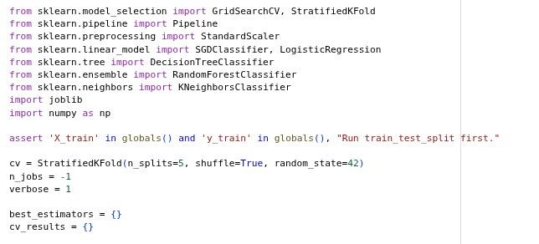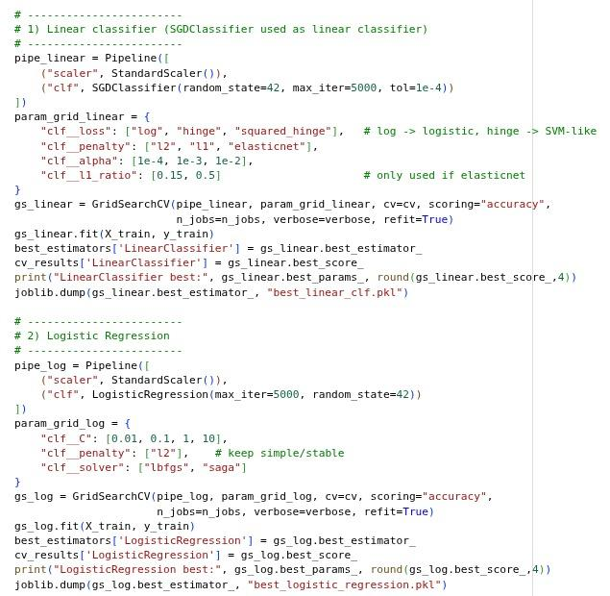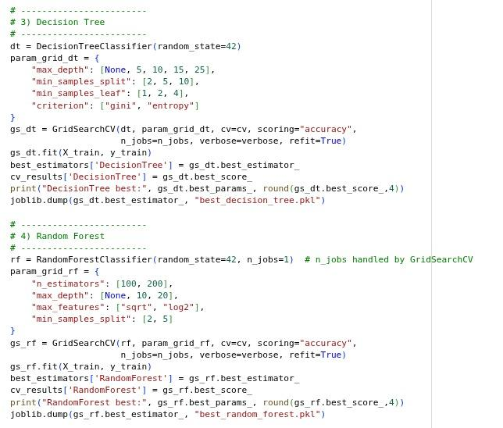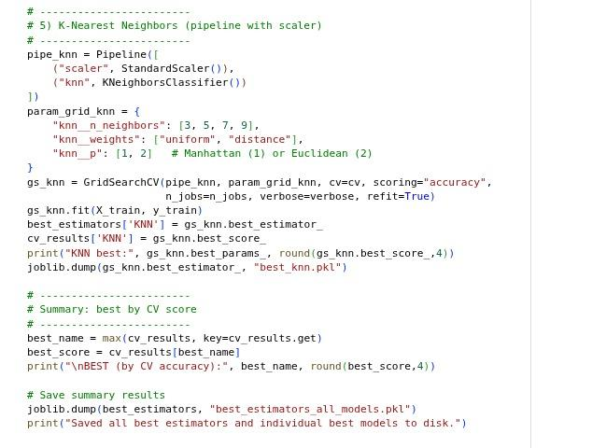

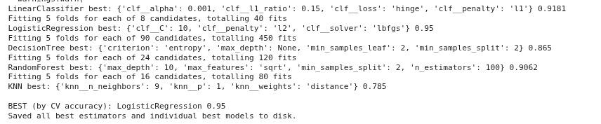
OUTPUT:-

COMPARISON AND EVALUATION

- CROSS-VALIDATION COMPARISON
Cross-validation is a technique used to evaluate the reliability and stability of a machine learning model by testing it on different subsets of the training data.
Working of K-Fold Cross-Validation:
- The training dataset is divided into K equal parts (folds), usually 5 or 10.
- The model is trained on K−1 folds.
- The remaining 1 fold is used for testing.
- This process is repeated K times, so each fold is used once as the test set.
- The final performance is calculated by averaging all K accuracy scores.

Q.1 HOW IT WORKS (K-FOLD CV EXAMPLE):
- Split training data into K folds (usually 5 or 10).
- Train on K-1 folds.
- Test on the remaining 1 fold.
- Repeat this K times (each fold becomes test once).
- Average all scores → CV accuracy.
Q.2 WHY IT MATTERS:
- Reduces overfitting risk
- Gives a more reliable accuracy
- Makes hyper-tuning fair
- Ensures model works well on unseen data

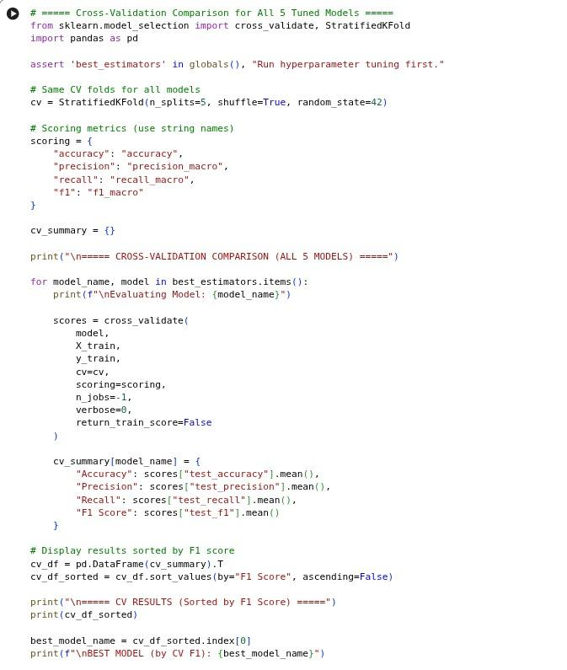
CODE:-
OUTPUT:-
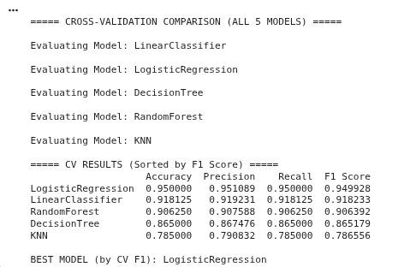
- FINALE TEST EVALUATION:-
Final Test Evaluation is the last and most important step in the machine learning pipeline. In this step, the best tuned model is evaluated using the test dataset (X_test, y_test), which contains data that the model has never seen before. This evaluation shows the true performance of the model in real-world conditions.
The model performance is analyzed using the following metrics:
1. CONFUSION MATRIX
- A confusion matrix is a 4×4 table because the target variable has four classes (0, 1, 2, 3).
- Rows represent the actual class, and columns represent the predicted class.
- Diagonal values show correct predictions, while off-diagonal values indicate misclassifications.
The confusion matrix helps in:
- Identifying which price ranges are predicted correctly.
- Understanding where the model gets confused between classes.
- Analyzing patterns of wrong predictions (e.g., class 2 predicted as class 3).
2. VISUAL REPRESENTATION OF CONFUSION MATRIX:

Visual Representation of Confusion Matrix
A confusion matrix is a visual tool used to evaluate the performance of a classification model by comparing actual class labels with predicted class labels.
In the visual representation:
- Rows represent the actual classes
- Columns represent the predicted classes
- Each cell shows the number of correct and incorrect predictions
The diagonal elements indicate correct classifications, while the off-diagonal elements represent misclassifications.
This visualization helps in understanding:
- Model accuracy
- Class-wise performance
- Types of errors made by the model
3. CLASSIFICATION REPORT
The classification report provides a detailed performance analysis for each class and includes:
- Precision: How accurate the model’s predictions are for each class.
- Recall: How well the model identifies all samples of each class.
- F1 Score: The balance between precision and recall.
- Macro Average: Average performance treating all classes equally.
- Weighted Average: Average performance considering class distribution.
4.TEST ACCURACY
- Test accuracy measures how many predictions were correct out of the total test samples.
- It gives an overall idea of the model’s correctness on unseen data.
Formula:
$Accuracy=\frac{Correct Predictions}{Total Predictions}$
Final Test Evaluation ensures that the selected model is accurate, reliable, and generalizes well to new data. It confirms whether the model is suitable for predicting mobile price ranges in real-world scenarios.

CONFUSION MATRIX:-
A confusion matrix is a table that shows how many predictions your model got correct and incorrect for each class.
Since your problem has 4 classes (0,1,2,3), the confusion matrix is a 4×4 grid.

Q.1 WHY IT'S IMPORTANT
A confusion matrix tells you:
- Which classes the model predicts correctly
- Where the model gets confused
- Which specific classes are difficult
For example:
- If many 1’s are predicted as 2 → model is confused between those two classes
- If zeros have perfect diagonal → model predicts class 0 very well
In your result
Logistic Regression’s confusion matrix:
[[100 0 0 0]
[ 1 96 3 0]
[ 0 3 96 1]
[ 0 0 2 98]]
Meaning:
- Class 0 → perfect
- Class 1 → a few predicted as 2
- Class 2 → a few predicted as 1
- Class 3 → almost perfect
This proves Logistic Regression is your best model.
CONFUSION MATRICES AND CLASSIFICATION REPORT FOR ALL 5 TUNED MODEL

AConfusion matrices and classification reports were used to evaluate all five tuned models. The confusion matrix shows correct and incorrect predictions for each price range class (0–3), helping identify misclassification patterns. The classification report provides precision, recall, F1-score, and overall averages, allowing a fair comparison of model performance beyond accuracy.
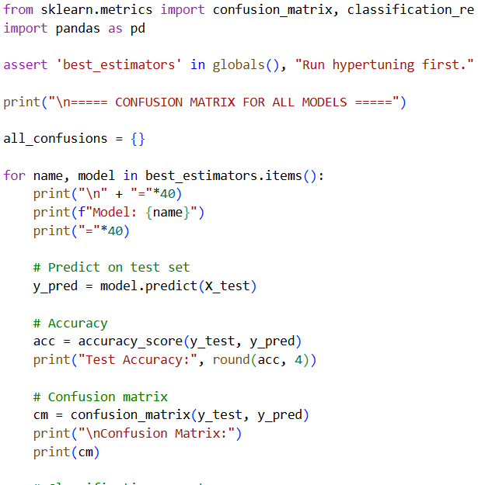
CODE:-

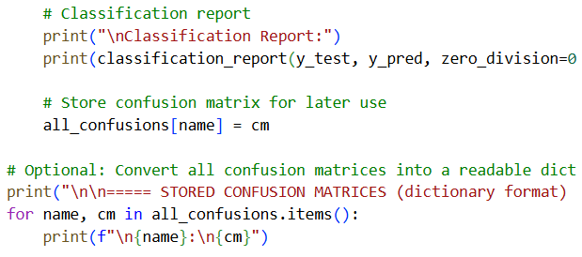
OUTPUT:-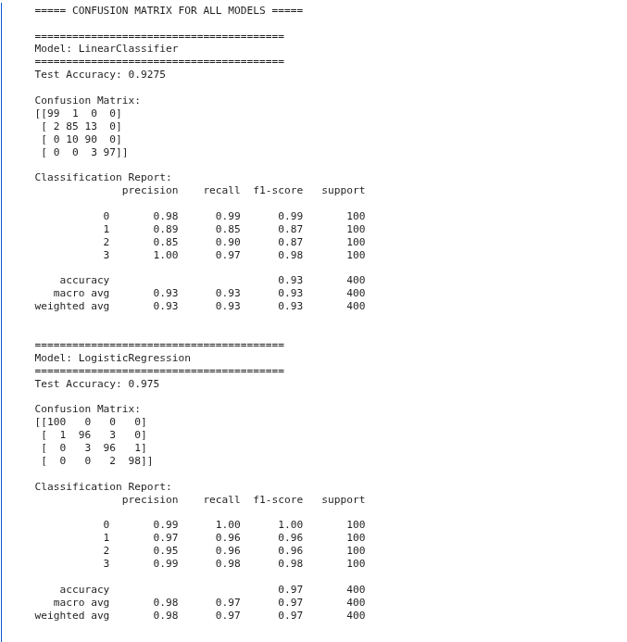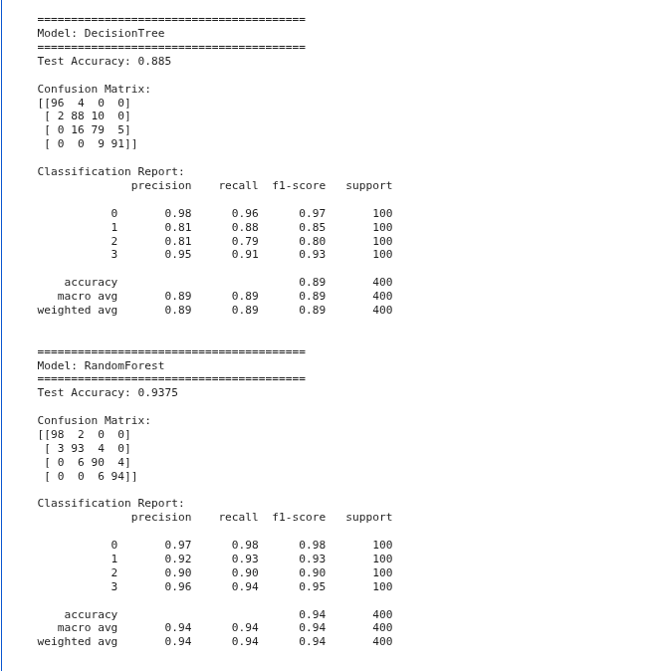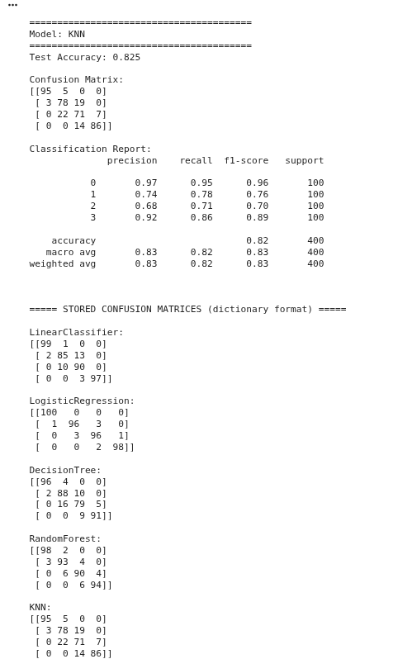

- CONFUSION MATRIX VISUAL REPRESENTATION
1. LOGISTIC REGRESSION
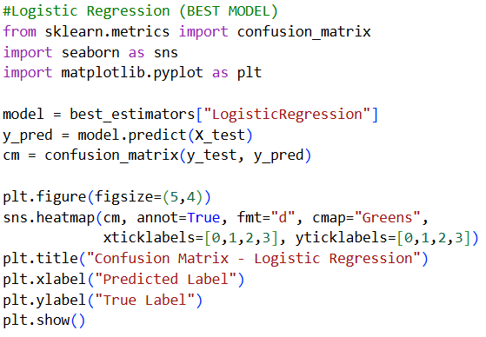
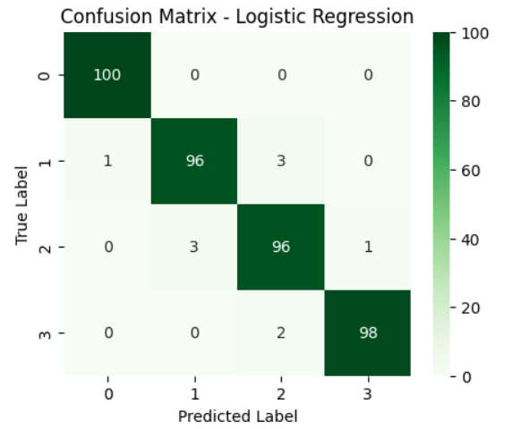
2 LINEAR CLASSIFIER
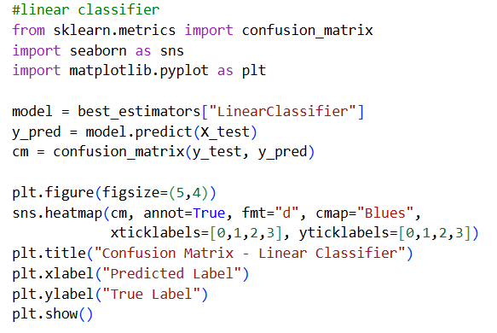
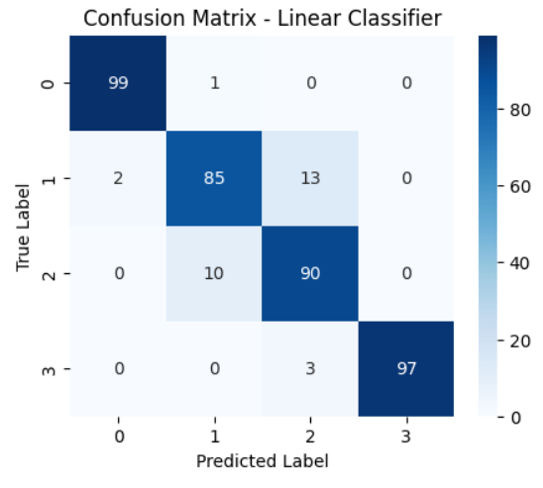
3.DECISION TREE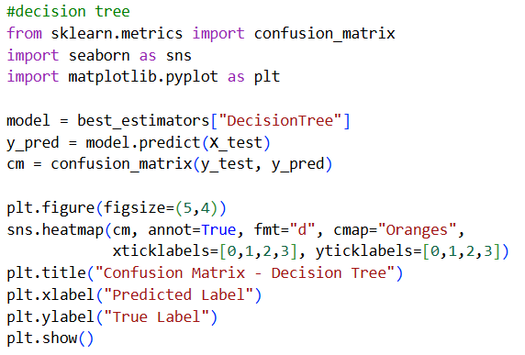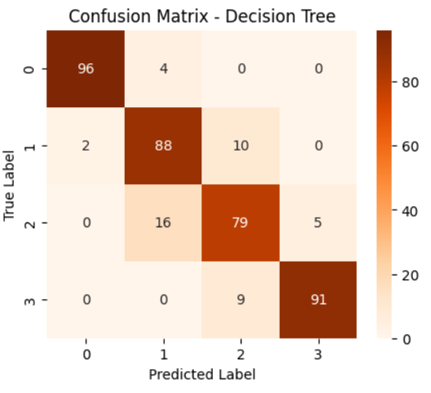
4 RANDOM FOREST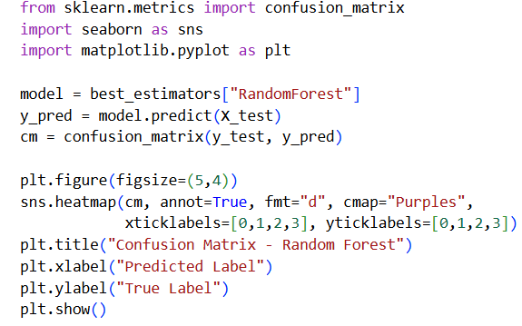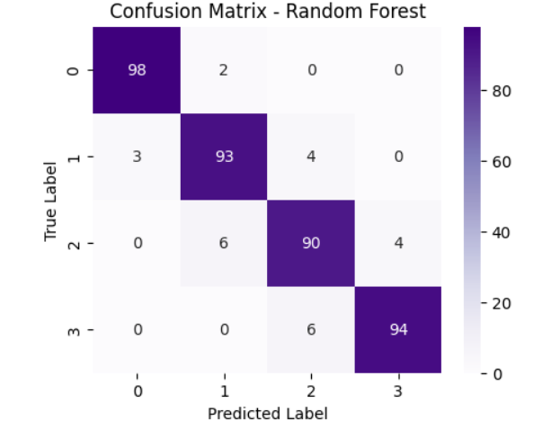

5 KNN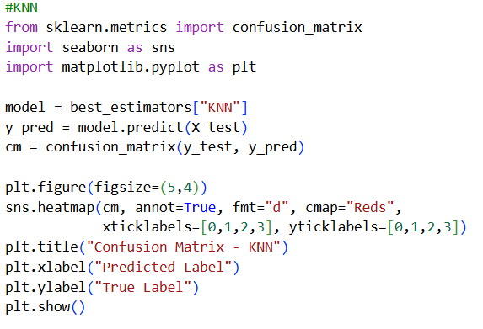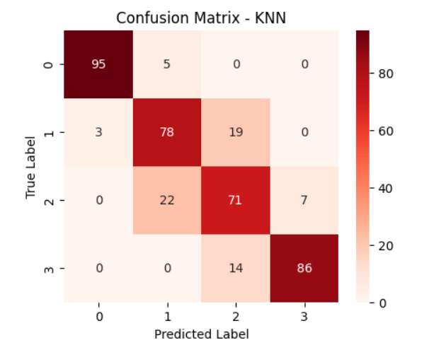

CLASSIFICATION REPORT
A classification report evaluates a model’s performance using four key metrics for each class (0–3):
- Precision: Percentage of correct predictions made for a class.
- Recall: Percentage of actual class samples correctly identified by the model.
- F1-score: Balanced measure of precision and recall.
- Support: Number of test samples in each class.
It also provides macro and weighted averages, which help assess overall model performance, especially when comparing different models.

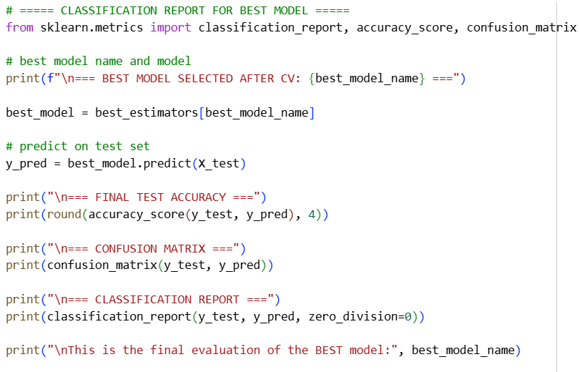
CODE:-
OUTPUT:-
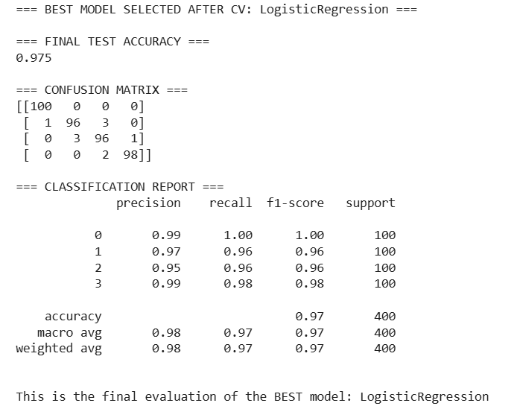
TEST ACCURACY
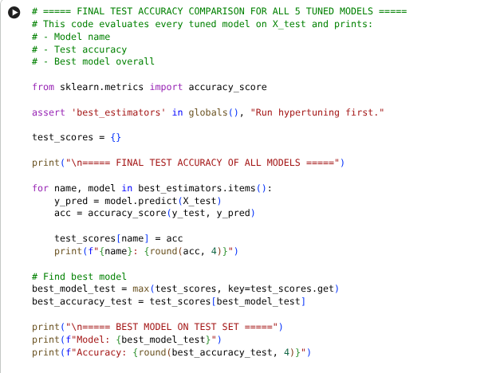
outlier:-
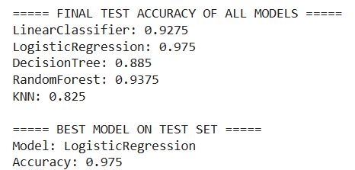
FEATURE IMPORTANCE:-
Feature importance is a technique used in machine learning to measure how much each input feature contributes to a model’s prediction.
It indicates which features have the greatest influence on the target variable and which features have little or no impact on the model’s output.
It shows:
- Which features strongly affect the price range
- Which features have low or no impact
- How the model prioritizes RAM, battery, resolution, PPI, storage, etc.

Q.1 WHICH MODELS GIVE FEATURE IMPORTANCE?
Yes (supports feature importance):
- Decision Tree
- Random Forest
- Logistic Regression (via coefficients)
- Linear Classifier (via weights)

Q.2 Why Feature Importance is Important
Feature importance helps to:
- Interpret and explain the model’s behavior
- Identify the most influential features
- Reduce model complexity by removing less important features
- Improve model performance and generalization
- Validate feature engineering decisions
DECISION TREE:-

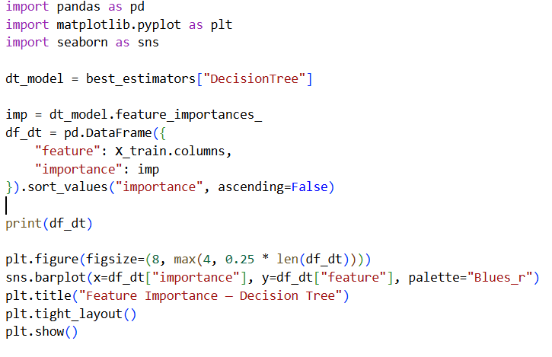
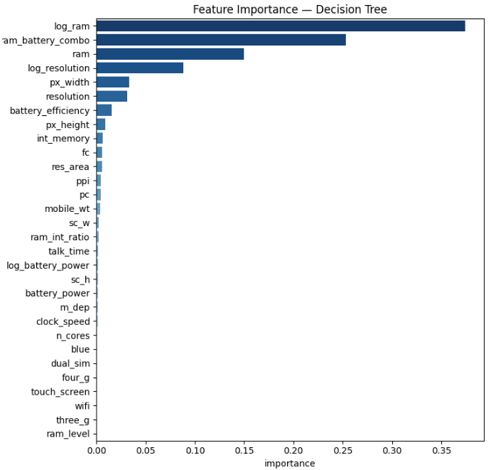
RANDOM FOREST:-

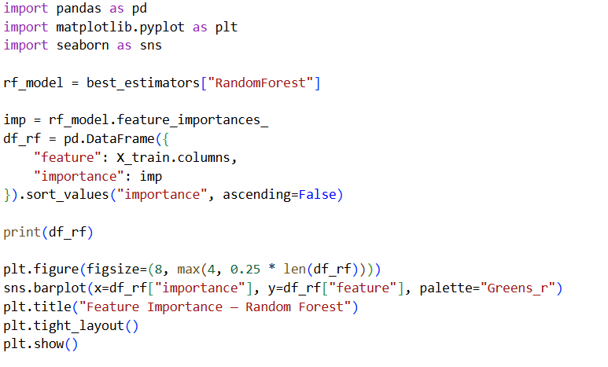

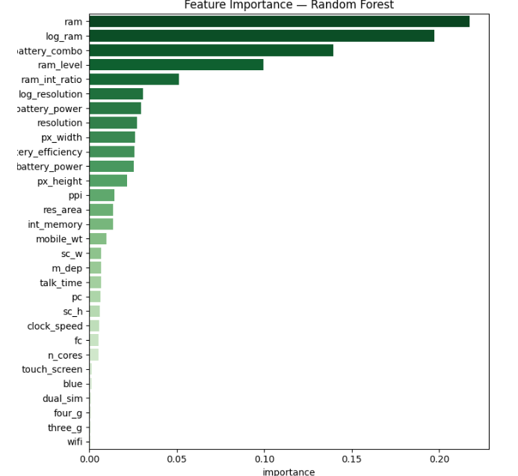

LOGISTIC REGRESSION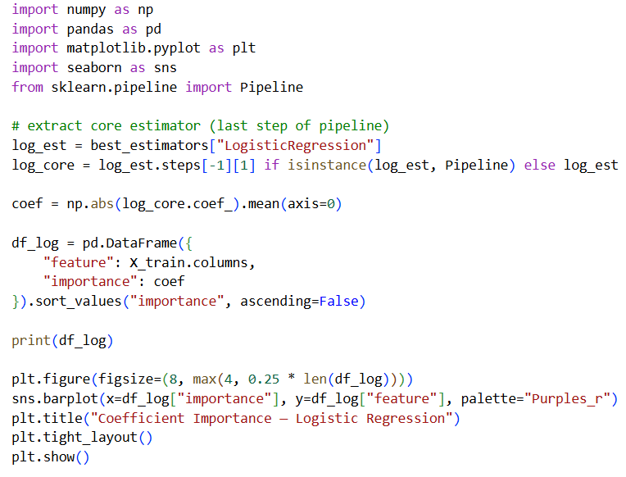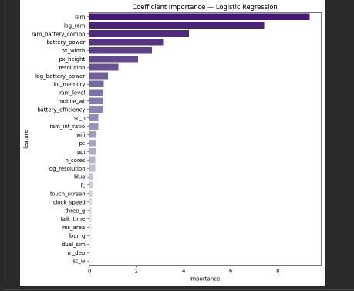

LINEAR CLASSIFIER SGD

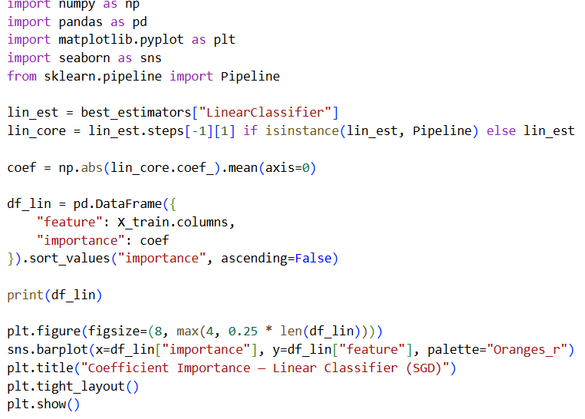

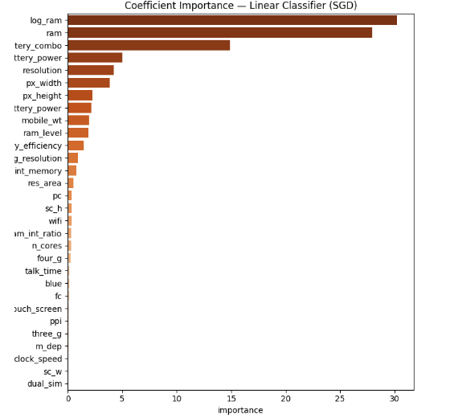

KNN:-
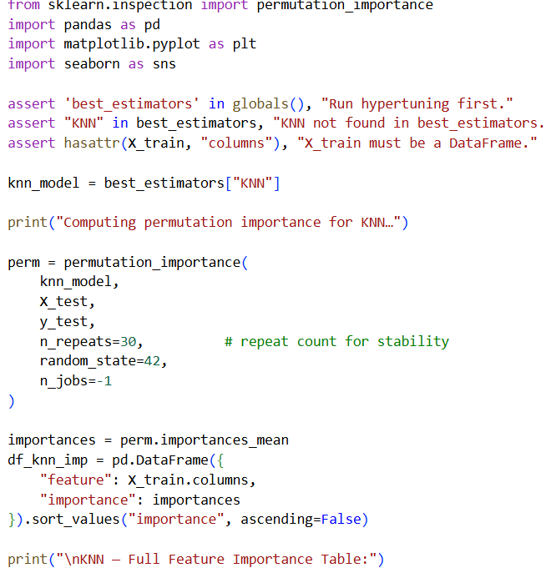
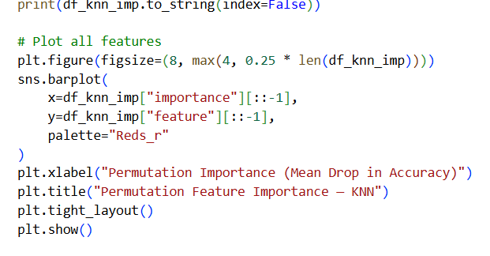:-
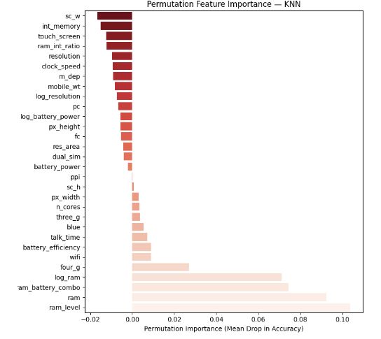
- SCATTER PLOT:-
A scatter plot is a graphical representation that shows the relationship between two numerical variables by plotting data points on an X–Y axis.
- Each dot represents one data sample.
- It helps identify patterns, trends, correlations, and outliers in the data.
- In this project, scatter plots are useful to visualize how features like RAM, battery power, or internal memory relate to the mobile price range.
Linear classifier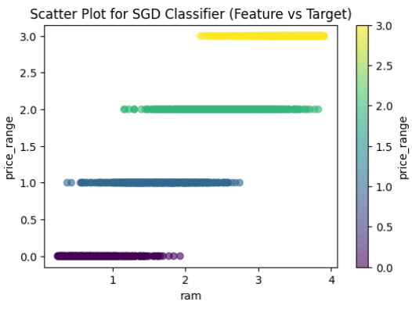 | Logistic regression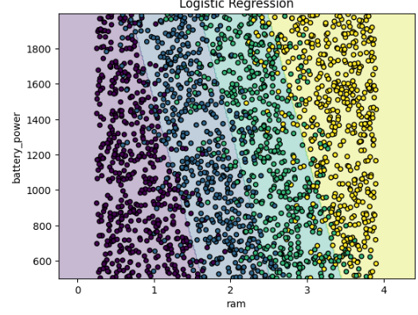
Decision tree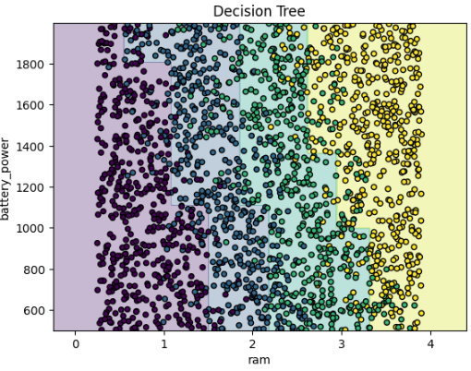 | Random forest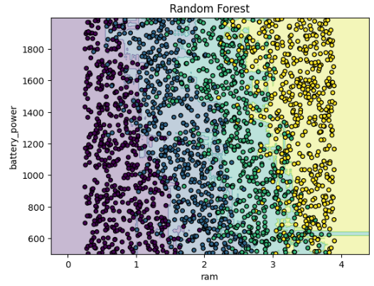
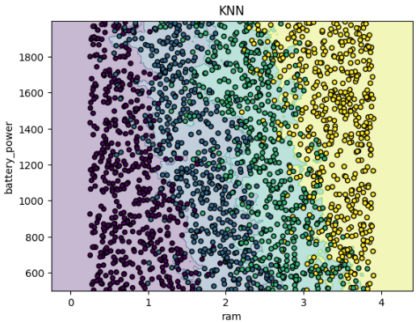
All 5 Model Comparison
- Model-wise Evaluation
1. SGD Classifier -linear

Test Accuracy: 92.75%
Error %: 7.25%
Advantages:-
· Simple and fast to train
· Works well with standardized features
· Interpretable coefficients
· Good baseline model
Disadvantages:-
· Assumes linear decision boundaries
· Slightly lower performance on overlapping classes (1 & 2)
· Less flexible than non-linear models
Observation:-
· Performs well but misclassifies mid-range price classes slightly more.

2. Logistic Regression
Test Accuracy: 97.5% (Highest)
Error %: 2.5% (Lowest)
Advantages:-
· Best overall accuracy, precision, recall, and F1-score
· Stable and consistent across all classes
· Handles multi-class classification very well
· Highly interpretable coefficients
· Low overfitting risk
Disadvantages:-
· Assumes linear separability in feature space
· Cannot capture very complex non-linear relations (without kernels)
Observation:-
· Almost perfect confusion matrix
· Balanced performance across all price ranges

3. Decision Tree
Test Accuracy: 88.5%
Error %: 11.5%
Advantages:-
· Easy to visualize and interpret
· Captures non-linear relationships
· No need for feature scaling
Disadvantages:-
· Prone to overfitting
· Sensitive to small data changes
· Lower generalization accuracy
Observation:-
· Struggles with class 1 and class 2 separation

4. Random Forest
Test Accuracy: 93.75%
Error %: 6.25%
Advantages:-
· Handles non-linear patterns well
· Less overfitting than decision tree
· Good feature importance insights
· Robust and stable
Disadvantages:-
· More computationally expensive
· Less interpretable than Logistic / Linear
· Slightly lower accuracy than Logistic Regression
Observation:-
· Very strong performer, but still behind Logistic Regression

5. K-Nearest Neighbors (KNN)
Test Accuracy: 82.5%
Error %: 17.5% (Highest)
Advantages:-
· Simple concept
· No training phase
· Captures local patterns
Disadvantages:-
· Sensitive to feature scaling and noise
· High prediction time
· Performs poorly in high-dimensional data
· Lowest accuracy among all models
Observation:-
· Confusion between mid-range classes is high

2️⃣ Comparison Table (Final Test Results)
Model | Accuracy | Error % | Precision | Recall | F1 Score
Logistic Regression | 97.5% | 2.5% | 0.98 | 0.97 | 0.97
Random Forest | 93.75% | 6.25% | 0.94 | 0.94 | 0.94
SGDClassifier- linear | 92.75% | 7.25% | 0.93 | 0.93 | 0.93
Decision Tree | 88.5% | 11.5% | 0.89 | 0.89 | 0.89
KNN | 82.5% | 17.5% | 0.83 | 0.82 | 0.83

Comparative Analysis
· Logistic Regression achieved the highest accuracy and lowest error rate.
· Random Forest performed well but slightly underperformed compared to Logistic Regression.
· SGDClassifier- linear showed strong results but lacked flexibility compared to Logistic Regression.
· Decision Tree suffered from overfitting and lower generalization.
· KNN performed the worst due to high dimensionality and sensitivity to feature scaling.
Across all models, Logistic Regression showed the most balanced precision, recall, and F1-score, indicating stable and reliable predictions across all price categories.
Best Model Selection
Selected Model: Logistic Regression
Justification:
Logistic Regression was selected as the best model because:
1. It achieved the highest test accuracy (97.5%)
2. It had the lowest error percentage (2.5%)
3. It showed consistent performance across all classes
4. Precision, recall, and F1-score were uniformly high
5. The confusion matrix showed minimal misclassification
6. The model generalized well during cross-validation
7. It is computationally efficient and easy to interpret

Conclusion
In this project, a comprehensive comparison of five machine learning classification models—SGD Linear Classifier, Logistic Regression, Decision Tree, Random Forest, and K-Nearest Neighbors (KNN)—was performed to predict mobile phone price ranges. Each model was trained, tuned, and evaluated using the same dataset and evaluation strategy to ensure a fair comparison.

Model-Wise Performance Summary
- SGD Linear Classifier demonstrated strong baseline performance with good accuracy and interpretability. However, due to its linear nature, it showed minor confusion between mid-range price classes.
- Logistic Regression emerged as the best-performing model, achieving the highest test accuracy (97.5%) and the lowest error rate (2.5%). It delivered consistently high precision, recall, and F1-score across all price categories, indicating stable and reliable predictions.
- Decision Tree effectively captured non-linear patterns but suffered from overfitting and lower generalization performance, especially when distinguishing between class 1 and class 2.
- Random Forest improved upon Decision Tree performance by reducing overfitting and providing robust predictions. Although it performed strongly, its accuracy remained slightly lower than Logistic Regression.
- K-Nearest Neighbors (KNN) recorded the lowest accuracy due to its sensitivity to feature scaling, noise, and high dimensionality. It struggled significantly with mid-range class separation.

Comparative Analysis
The comparative evaluation clearly highlights that:
- Logistic Regression achieved the highest accuracy and lowest error rate.
- Random Forest performed well but did not surpass Logistic Regression.
- SGD Linear Classifier delivered competitive results but lacked non-linear flexibility.
- Decision Tree faced overfitting challenges.
- KNN underperformed due to data complexity and dimensionality.
Across all evaluation metrics—accuracy, precision, recall, and F1-score—Logistic Regression maintained the most balanced and consistent performance.

Best Model Selection

Selected Model: Logistic Regression

Justification:
Logistic Regression was selected as the final model because:
- It achieved the highest test accuracy (97.5%)
- It had the lowest error percentage (2.5%)
- It showed balanced precision, recall, and F1-score
- It produced a nearly perfect confusion matrix
- It generalized well during cross-validation
- It is computationally efficient
- It offers high interpretability, making results easy to explain

Final Remark
This project demonstrates that careful data preprocessing, feature engineering, and model selection play a crucial role in achieving high predictive performance. Among all tested models, Logistic Regression proved to be the most reliable and effective approach for mobile price range classification.

CONCLUSION
In this project, a comprehensive comparison of five machine learning classification models—SGD Linear Classifier, Logistic Regression, Decision Tree, Random Forest, and K-Nearest Neighbors (KNN)—was performed to predict mobile phone price ranges. Each model was trained, tuned, and evaluated using the same dataset and evaluation strategy to ensure a fair comparison.

Model-Wise Performance Summary
- SGD Linear Classifier demonstrated strong baseline performance with good accuracy and interpretability. However, due to its linear nature, it showed minor confusion between mid-range price classes.
- Logistic Regression emerged as the best-performing model, achieving the highest test accuracy (97.5%) and the lowest error rate (2.5%). It delivered consistently high precision, recall, and F1-score across all price categories, indicating stable and reliable predictions.
- Decision Tree effectively captured non-linear patterns but suffered from overfitting and lower generalization performance, especially when distinguishing between class 1 and class 2.
- Random Forest improved upon Decision Tree performance by reducing overfitting and providing robust predictions. Although it performed strongly, its accuracy remained slightly lower than Logistic Regression.
- K-Nearest Neighbors (KNN) recorded the lowest accuracy due to its sensitivity to feature scaling, noise, and high dimensionality. It struggled significantly with mid-range class separation.

Comparative Analysis
The comparative evaluation clearly highlights that:
- Logistic Regression achieved the highest accuracy and lowest error rate.
- Random Forest performed well but did not surpass Logistic Regression.
- SGD Linear Classifier delivered competitive results but lacked non-linear flexibility.
- Decision Tree faced overfitting challenges.
- KNN underperformed due to data complexity and dimensionality.

Across all evaluation metrics—accuracy, precision, recall, and F1-score—Logistic Regression maintained the most balanced and consistent performance.

Best Model Selection

Selected Model: Logistic Regression

Justification:
Logistic Regression was selected as the final model because:
- It achieved the highest test accuracy (97.5%)
- It had the lowest error percentage (2.5%)
- It showed balanced precision, recall, and F1-score
- It produced a nearly perfect confusion matrix
- It generalized well during cross-validation
- It is computationally efficient
- It offers high interpretability, making results easy to explain

Final Remark
This project demonstrates that careful data preprocessing, feature engineering, and model selection play a crucial role in achieving high predictive performance. Among all tested models, Logistic Regression proved to be the most reliable and effective approach for mobile price range classification.

